

|  |  |  |
| --- | --- | --- |
| **QUANTITATIVE SCIENCES DEPARTMENT** | |  |
| **Course:** **A1MAA** | |
| **Topic Title**: Investigation 3 – Pythagoras Theroem  **Part 2** –  **In-class Validation** | |
| Student Name:_____________________________________ | Date: __________2015 | | |
| Special Instructions: Notes allowed –(copy of the solutions to Part 1) and | Time Allowed: 1 hour | | |
| calculator | Marks: / 44 | | |

**Question 1 (8 marks)**

Jim cycles 3 km West from the start of the race (S), then turns North travelling 7 km before heading West again and cycling a distance of 5 km to his finishing point, W. where he stops. Meanwhile Tony starts from the same position (S) at the same time as Jim started and cycles 8 km East before heading North for 20 km to his finishing point, (E).

(a) Draw a labelled sketch to represent these travels. (3)

(b) If they both end their journeys at the same time, who has averaged the greater speed?

Justify your answer. (2)

(c) Show how you apply Pythagoras’ theorem to determine how far Jim is from Tony when they finish their race. (3)

**Question 2 (5 marks)**

Calculate the length of string needed to go all around the outside of this child’s toy kite in which the pieces of dowel, with measurements in cm, are perpendicular to each other.

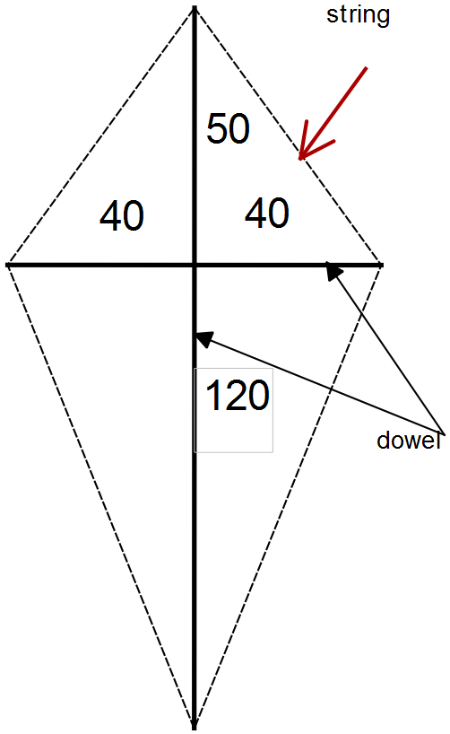

**Question 3 (8 marks)**

Four wooden stakes, each 2 m long, are placed around a small tree so that they meet directly above the top of the tree. On the ground, the end of each stake is 1.5 m from the centre of the base of the tree.

(a) Label the diagram provided with the given dimensions. (2)

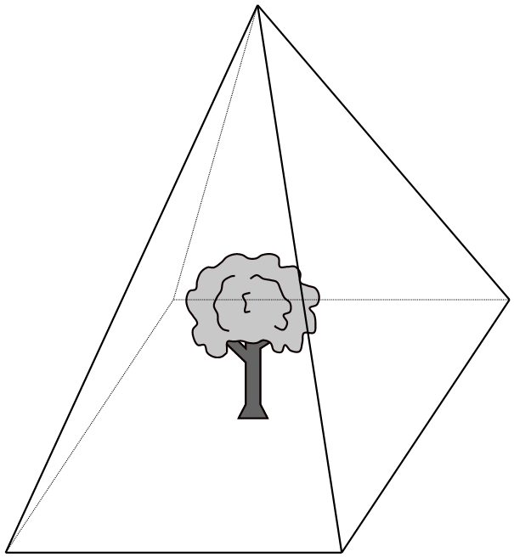

(b) What is the distance from the base of the tree to the point where the stakes meet? (2)

(c) What is the distance from the base of one stake to the base of the next stake? (2)

(d) Calculate the area of the base of the pyramid formed by the four stakes. (2)

**Question 4 (4 marks)**

A rectangular section of the side fence around the tennis court is represented by the diagram below.

The fence is attached to a metal support which is

made up of three sections.

Use Pythagoras’ theorem to determine the length

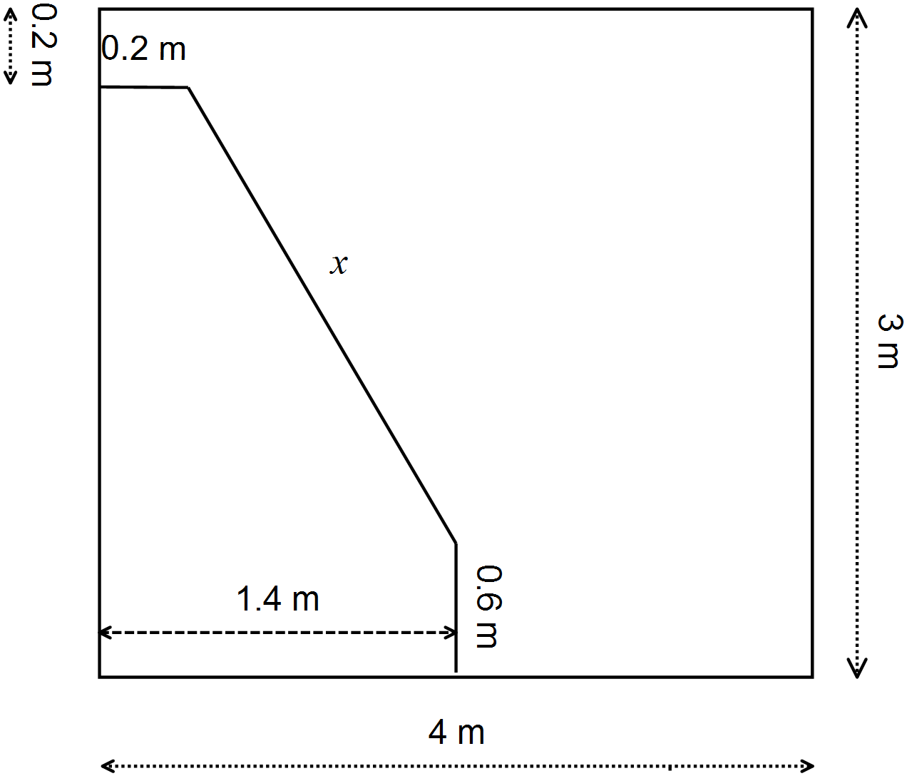

of the section labelled *x*.

**Question 5 (6 marks)**

The diagram shows part of a junior soccer field: BD is 6 m and DC is represented by *k*.

Write algebraic expressions for each of the following lengths.

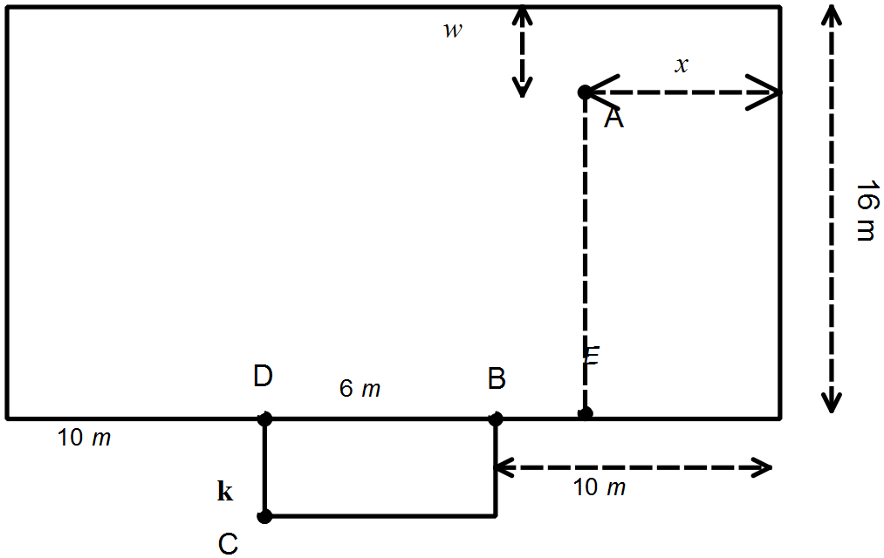

Do not simplify these expressions.

(a) AE (1)

(b) BE (1)

(c) AB (2)

(d) BC (1)

(e) The distance a ball will travel if it is kicked A to B to C. (1)

**Question 6 (8 marks)**

A straw, 23 cm in total length, protrudes 8 cm from the edge of a juice box which is in the shape of a rectangular prism. The box is 10 cm high and 9 cm in length.

(a) Draw a labelled diagram to represent this situation. (3)

(b) Use Pythagoras’ theorem to determine the width of the box. (5)

**Question 7 (5 marks)**

The diagram below shows the cross section of a carton containing 4 cylindrical tins, each 7 cm across.

Use Pythagoras’ theorem to determine the width of the widest cylinder (the one shaded) that can

fit in between these tins.

